This is what is preferred, is to have the filtering activated or default to open when the list is initially accessed.

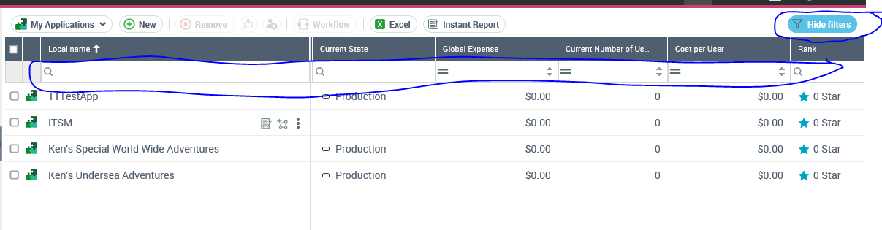

This is the OOB behavior to have the filtering collapsed.
