- My descriptor :
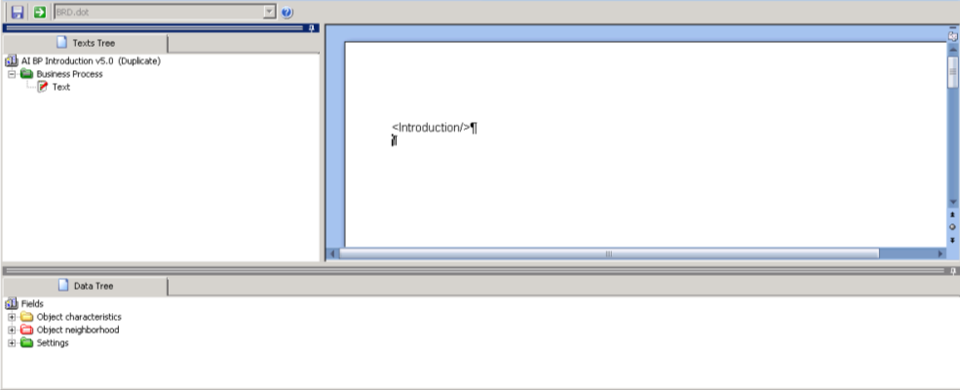
- My document template
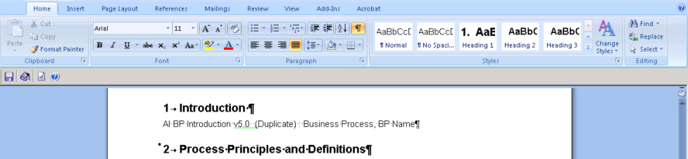

- A document generated using the template above :
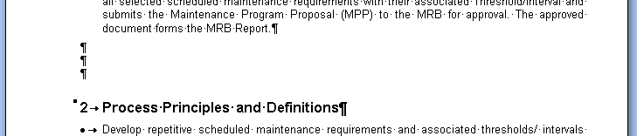

I would like to be able to manage the spacing after the descriptor (before 2. Process Principles and Definitions).

