Error message received when trying to connect to
environment:GLOBE
repository:development

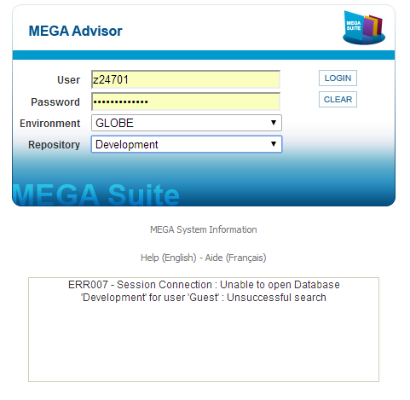

When I click : MEGA system information

