Creating a new web site
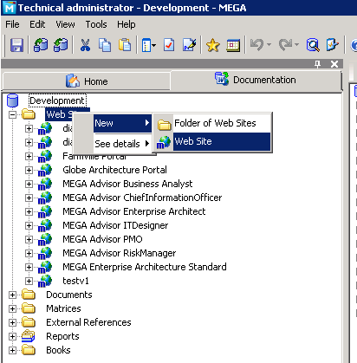
Name: megaonline
Generation folder:\\frmadv01\megadevelopment\globe\intranet\megaonline
From website template: MEGA Advisor Business Analyst

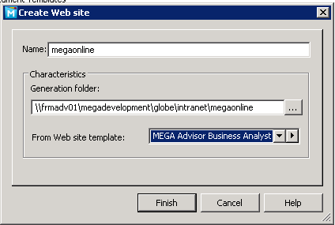

Generate:
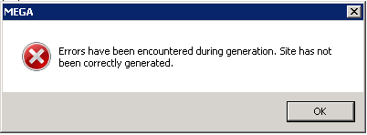
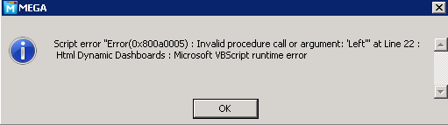

Html Dynamic dashboard properties
